Shopaholic vs. Automatonophobia
購物狂及假人恐懼症
Shopaholic
If you hide credit card bills, shopping bags or receipts, you may be a shopaholic. Some of the other emotional symptoms you may notice from a shopaholic include the following:
- Shopping as a way to feel less guilty about a previous shopping spree
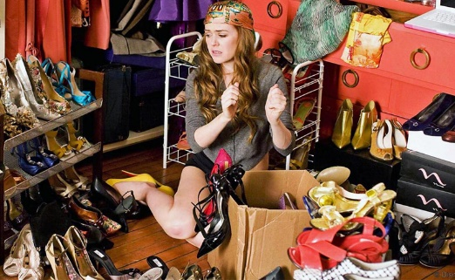
- Spending more than they can afford
- Shopping as a reaction to feeling angry or depressed
- Harming relationships due to spending or shopping too much
- Losing control of the shopping behavior

Ask yourself the following questions. If you answer “yes” to many of these questions, you may have an addiction. The questions are:
- Do you shop when you feel angry or disappointed?
- Has overspending created problems in your life?
- Do you have conflicts with loved ones about your need to shop?
- While shopping, do you feel rushes or anxiety?
- After shopping, do you feel like you have just finished doing something wild or dangerous?
- After shopping, do you ever feel guilty or embarrassed about what you have done?
- Do you frequently buy things that you never end up using or wearing?
- Do you think about money almost all the time?

People who suffer from shopping addiction may experience anxiety when they’re not shopping and may talk or think non-stop about shopping and making purchases. Many of these individuals lose interest in the items they buy as soon as they get home, and won’t even use them. Financial hardship is a common sign of shopping addiction, as well as evidence of new, unused items around the home that seem to keep piling up.

Key characteristics that people with shopping addictions tend to share:
- Approval-Seeking
The shopaholic personality has been found to be more kindhearted, sympathetic, and not rude to others. Often lonely and isolated, the shopping experience provides the shopaholic with positive interactions with salespeople and the hope that what they have bought will improve their relationships with others Shopaholics also have a tendency to be easily influenced by others.
- Low Self Esteem
Shopping is a way of trying to improve self-esteem, particularly when the desired object is associated with an image of what the shopper wants to be. However, low self-esteem can also be a consequence of shopping addiction. For example, debt can intensify feelings of inadequacy and worthlessness.
- Emotional Problems
Excessive shopping can often become a crutch to cope with emotions. People find themselves buying things to make themselves feel better when they are sad, stressed, angry, bored, or afraid. Studies have also found that shopping addicts often suffer from anxiety and depression.
- Poor Impulse Control
Most people find it fairly easy to control their impulses and learn to do so during childhood. However, shopaholics find impulses overwhelming and irresistible, especially impulses that involve buying something.
Shopping can sometimes become a way of gaining an illusory sense of control so the shopaholic seeks out great deals and buying unneeded items just because they are on sale.
- Indulges in Fantasy
The shopaholic can imagine all the positive consequences of buying the desired object, and they can escape into a fantasy world to escape the harsh realities of life.

Medication and Treatment
Many shopaholics have been able to successfully treat their addictions by turning to anti-anxiety medications or even antidepressant medications.
According to Donald Black from the University of Iowa, as quoted in Esperanza magazine, nearly two-thirds of all shopaholics struggle with depression or anxiety. In order to effectively treat your shopping addiction, you may also need to deal with your other mental health issues.
Commonly used therapy and resource: behavioral therapy, cognitive therapy, financial counseling, self-help books, support groups, and medications.

Automatonophobia
A fear of human-like figures, such as mannequins, wax figures, statues, dummies, animatronics, or robots.

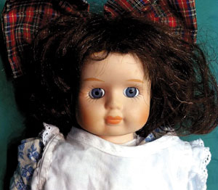
What are the symptoms of automatonophobia?
psychological symptoms | physical symptoms
- agitation  - restlessness  - constant worrying  - decreased concentration  - trouble sleeping  - anxiety attacks | - increased heart rate  - difficulty breathing and chest pain  - nausea  - diarrhea  - sweating and shaking  - dizziness and disorientation

When automatonophobia develops because of a traumatic event related to human-like figures, it’s known as an experiential phobia. This traumatic event could be a scary movie with human-like figures or an in-person event involving human-like figures.

When automatonophobia develops without a traumatic event, it’s known as a non-experiential phobia. These phobias can develop for a variety of reasons, such as:
- Genetics: Having a relative with automatonophobia can increase the risk that you may develop the same phobia.
- Development: Early development of the brain may make someone more susceptible to developing this type of phobia.

Doctors use diagnostic criteria from the Diagnostic and Statistical Manual of Mental Disorders, Fifth Edition (DSM-5) to diagnose a phobia. You may have a specific phobia like automatonophobia if:
- you experience a persistent, excessive, or unreasonable fear of human-like figures
- exposure to human-like figures leads to immediate anxiety symptoms or panic attacks
- your fear is disproportionate to the threat that these human-like figures pose to you
- you actively avoid any situation in which you will have to see or be around human-like figures; or if you’re put in a situation where you’re exposed to them, you experience intense anxiety
- your quality of life and daily functioning is severely affected by this fear
- you have had this fear for at least 6 months, and it’s constant
- there are no other underlying mental disorders that are primarily causing this fear

Treatment for automatonophobia
- Cognitive behavioral therapy
CBT is a popular form of psychotherapy that teaches you how to challenge your negative thought patterns so that you can change your behavior patterns.
- Exposure therapy
For people with automatonophobia, this therapy can greatly help improve quality of life, especially if the person has been avoiding activities due to their fear. Frequent safe exposure can also help to reduce the immediate fear response and anxiety symptoms that happen when a person is exposed to human-like figures.
- Experimental therapies
Virtual reality therapy is a more recent approach to phobia therapy that involves immersion into a virtual reality to allow someone to interact with or be exposed to their fear.
- Medications
While antidepressants may be used to treat the symptoms of automatonophobia in the long term, benzodiazepines may be used for short-term symptoms. However, a mental health professional may not prescribe medications like benzodiazepines due to the increased risk for dependence.
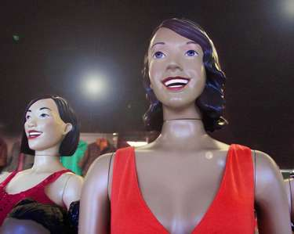
https://www.healthline.com/health/anxiety/automatonophobia#treatment
https://www.verywellmind.com/inside-the-mind-of-a-shopaholic-22179
https://www.psychguides.com/behavioral-disorders/shopping-addiction/
https://www.addictions.com/shopping/
https://www.healthline.com/health/addiction/shopping#outlook

Video:
Automatonophobia images with unnerving music
- https://www.youtube.com/watch?v=ygpEPLdmbhM
- https://www.youtube.com/watch?v=OtsXj1_1xj0

