Misophonia vs. ASMR
Misophonia
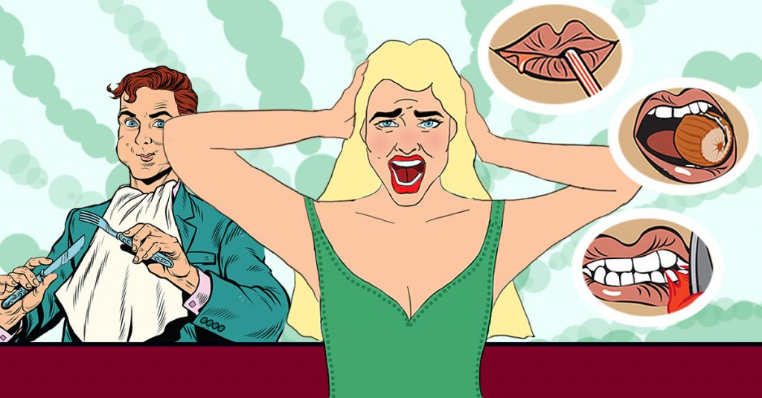
Is misophonia real?
There are times when chewing, pen tapping, or other little noises bothers us to no end. For those with a condition known as misophonia, however, those sounds are more than just annoying — they can be unbearable.

First named as a condition in 2001, “misophonia” is the ancient Greek word for “hatred of sound.” Also known as selective sound sensitivity syndrome, it’s a genuine abnormality of the brain with both psychological and physiological symptoms. In a recent study, MRI scans showed a marked difference in 1) the brain structure of those who have misophonia and 2) the way their brains react when hearing trigger sounds.

Misophonia triggers
Triggering sounds vary among people with misophonia and may change over time. The most common triggers are those that come from other people’s mouths. This includes:

- chomping  - slurping  - swallowing  - throat clearing  - lip smacking | - sniffling  - writing sounds  - papers rustling  - ticking clocks  - car doors slamming  - the sounds of birds, crickets, and other animals

Almost any sound can be a potential trigger. Some with misophonia also have visual triggers. This can include:
- foot wagging
- nose rubbing
- hair twirling

What misophonia feels like?
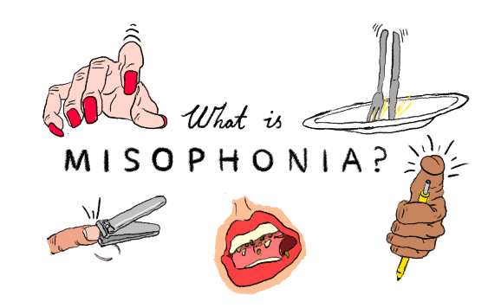
The best way to describe what happens when someone with misophonia hears or sees a trigger may be to think about what it’s like for most people to hear nails on a chalkboard. Your skin prickles, your nerves flare, and you just want it to stop immediately. For most, that occurs just once in a while. People with misophonia, however, may experience that sensation on a daily basis because of sounds other people hardly notice.

Dr. Barron Lerner, a doctor and NYU professor who has misophonia, explains that, in a word, trigger sounds feel awful. “Like your blood is starting to boil. [There are] lots of anxious feelings, like heart racing and stomachache.”

What causes misophonia?
Researchers don’t know yet what causes misophonia. There appears to be a higher occurrence of the disorder among people who also have the following conditions:
- obsessive-compulsive disorder (OCD)
- anxiety disorders
- Tourette syndrome
It also appears to be more common in people who have tinnitus. Tinnitus is a different disorder in which you hear sounds, like a ringing in your ears, that no one else can hear.

Johnson points out that for years, people with misophonia were misdiagnosed with anxiety, phobias, and other disorders. But misophonia is a unique disorder with its own special characteristics, including the following:
- The onset of misophonia is generally before puberty, with the first symptoms occurring most frequently between the ages of 9 to 12.
- More women than men have misophonia.
- People with misophonia tend to have higher IQs.
- The initial trigger sound typically is an oral sound from a parent or family member, and new triggers arise over time.
- There’s likely a genetic component as it often runs in families.

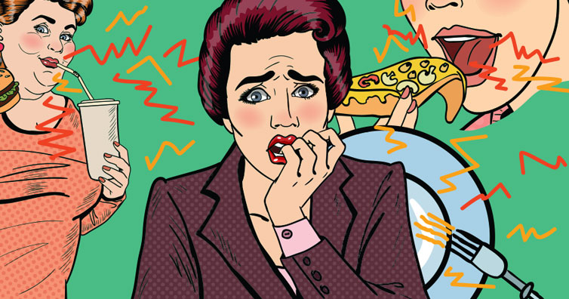
How to cope with misophonia?
While misophonia is a lifelong disorder with no cure, there are several options that have shown to be effective in managing it:
1. Tinnitus retraining therapy
In one course of treatment known as tinnitus retraining therapy (TRT), people are taught to better tolerate noise.

2. Cognitive behavioral therapy
CBT is another type of therapy that may help change the negative associations you have with triggering noises. According to Johnson, ear-level devices that stream audio of rain, nature, or other sounds have proven particularly effective, with 85 percent of users experiencing a relief in symptoms.

3. Counseling
Supportive counseling for both the person with misophonia and their family is also important, as the condition can affect the entire family.

At this time, there are no medications approved by the U.S. Food and Drug Administration to treat misophonia and no conclusive scientific evidence that any medication is effective in its treatment. Johnson asserts that most people with misophonia are able to overcome its challenges. “From what I can tell after 20 years of following misophonia sufferers, most go on and have good lives,” Johnson said. “Many have children and incredible careers, and that’s important for young kids suffering from this disorder now to know.”

ASMR
ASMR is a pleasurable tingling sensation that some people get in the crown of their head that spreads to the neck and back. It’s a pleasant experience that’s even sometimes referred to as “brain orgasms.” People say it helps reduce anxiety and depression and promote sleep. One survey found that 98 percent of people use ASMR to relax, 82 percent used it to help them sleep, and 70 percent use it to deal with stress.

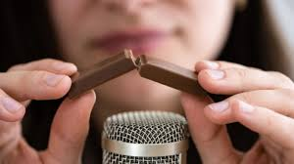
Some People Can’t Stand ASMR
“The first time I heard an autonomous sensory meridian response—or ASMR—video, my sound sensitivities were triggered, but not in a good way. I was so creeped out that I could only listen for a few seconds.”

Youtube has millions of ASMR videos showing people whispering, crinkling paper and tapping on tables. People rave about ASMR as a self-care tool, and YouTube ASMR channels rack up millions of viewers. It’s become ingrained in pop culture, and was even featured in Michelob Ultra Gold’s Super Bowl commercial this year, starring actress Zoe Kravitz whispering into a microphone while surrounded by a mountain landscape. The ad has more than 14 million views on YouTube.

Those who love ASMR get an involuntary pleasant warm and tingling sensation which leads to a calm, relaxed feeling that reduces anxiety. “I feel the opposite when I hear ASMR videos. I feel creeped out, stressed, anxious, and even angry—no tingles.”

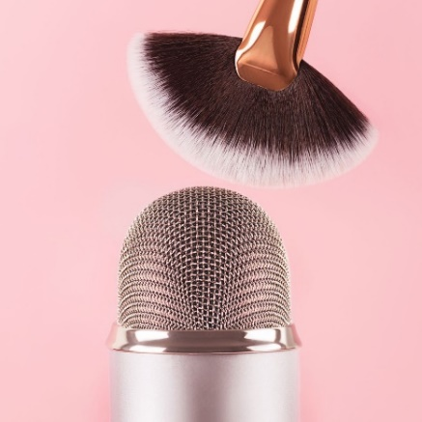
Most ASMR research has relied on self-reporting from experiencers. A 2018 study published in the journal PLOS ONE revealed that tingling sensations and positive reactions occurred only in people who said they experience ASMR. They also showed reduced heart rates and increased skin conductance levels when watching ASMR videos.
Brain scans on people who reported being ASMR experiencers found that the areas of the brain associated with the reward system and emotional arousal light up when they watch ASMR videos, according to another 2018 study.
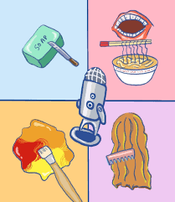
ASMR haters may have misophonia.
Feeling anger, anxiety or agitation from the sounds in ASMR content could be a sign of the condition misophonia, or “hatred of sound.” Chewing, whispering, yawning and other sounds can spark a strong negative emotional response for people with misophonia.

Experiences and expectations can affect feelings about ASMR.
ASMR is closely linked to past experiences, with the sensation resembling feeling nurtured as a child. This can be comforting to some, Gerrol says. “For some people, perhaps there was something that was not pleasant in their childhood, those same sensations can actually be something they recoil against,” he says.

ASMR Video:
- Beer Ad: ULTRA Pure Gold Super Bowl Commercial with Zoe Kravitz ASMR
- rubbing items: ASMR 99.99% of YOU will fall asleep
- talking: ASMR | Very Close Up Whispering & Telling You Stories
- eating: ULTIMATE BEST CRISPY! BBQ Hot Golden Olive Fried & Red Chak Chak Chicken Mukbang
- ASMR hater: Listening to ASMR Sounds I HATE Until it Triggers My Misophonia

https://www.healthline.com/health/misophonia#what-it-feels-like
https://www.menshealth.com/health/a26990905/why-asmr-doesnt-work/
https://daveasprey.com/what-is-asmr/

