Western Sydney University Summer Camp in Tamkang University

Advanced Green Materials and Water Technologies: July 4-17, 2019

Course Topic
Wetlands and River Corridors and Their Restoration
Dr. Wei-Ta Fang
Brief Introduction | Topic  Asian Wetlands and their International Connections:  A Sensitive Climate Resilience Perspectives for Wetland Designs  Lecturer  Professor Wei-Ta Fang (方偉達教授) National Taiwan Normal University  Abstract  The first concept of 'self-organization' has been stated in 1920s by Lotka.  He assumed that ecosystems are networks of energy flows. Decades later, Odum (1989) devised a thermodynamic model for the development of the ecosystem. He used this concept on pond designs for wastewater treatment between waste ponds and control ponds as reference sites. He believed that a self-organized system could provide stabilized capacities in facing environmental fluctuations and ecological competitions. In this ecosystem, the species stays pretty much the same in a short-term, while the material is constantly being replaced by new material, part of which comes from matter (nutrient, air, water) and part of which comes from energy (sun). Currently, McHarg, Kauffman, and Mitsch have pioneered the 'self-design' concepts (McHarg 1969; Kauffman 1993; Mitsch and Gosselink 2000). Mitsch and Wilson (1996) suggest that more time is necessary for restoration sites to achieve design progress. For example, freshwater marshes may require 15-20 years rather than the normal 5 years to see change. Restoration of forested wetlands probably require longer. They suggested using ecosystem modeling to provide guidance on when restoration sites can be expected to comply with self-organization. In Taiwanese study area, there are two major challenges in wetland restoration. First, hydrological and nutrient alternations are common by human construction and fertilizer overloading. In the aspect of hydrology, rivers, channels, and farm ponds are directly changed hydrological frequency and duration by ditching, diking, draining, and damming. Second, physical changes associated with road and building construction also cause geomorphologic changes both in the wetlands and adjacent areas. I, therefore, applied the cases in Taiwan as an interaction between aquatic and terrestrial biome in riparian wetlands for the aforementioned reasons. In my study area, flood, fertility, disturbance, and competition have been selected to measure vegetation hierarchies. Vegetation communities seem quite certain in response to natural and anthropogenic influences so that the predicting results will be more secure than that of animal species. In addition, wetland vegetation communities are easy to count with continuous canopies and to measure their structures and functions from sensitive climate resilience. The self-organization concept is utilized available species to understand the progressive rate of the study area in Asia.  Keyword: riparian wetlands, restoration, self-organization, vegetation.  Reference:  https://www.springer.com/us/book/9789400705500

Course Topic
Water Treatment Technologies
Dr. Ching-Yu Peng
Brief Introduction | Topic  Techniques of Wastewater Treatment  Lecturer  P.E. Pochen Chen (陳伯珍 老師)  Watch Video  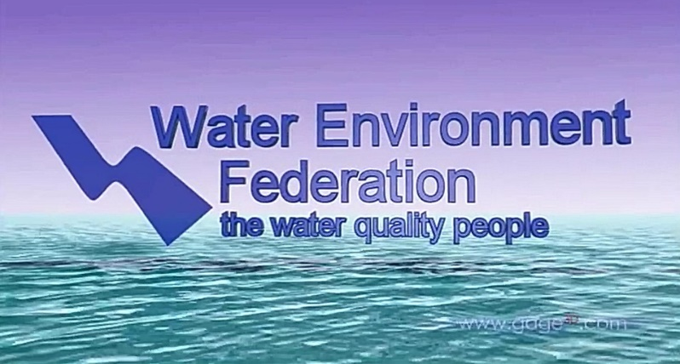  The class will start with a 10-minute English-narrated video “Water Resource Recovery Facility 3D Virtual Tour”. This virtual tour of a water resource recovery facility - commonly called a wastewater treatment plant - discusses how these facilities recycle the water and waste we flush down the drain. Water resource recovery facilities can also recover nutrients, generate energy, and create biosolids for use as fertilizer. This tour takes viewers through primary, secondary, and advanced treatment as well as the plant headworks and biosolids treatment process. The video was developed by the U.S. Water Environment Federation.  Video on  “Water Resource Recovery Facility 3D Virtual Tour”→  - Give Lessons  After taking the virtual tour of a wastewater treatment plant, the class will have lessons covering various unit operations and unit processes commonly used in wastewater treatment plants. These processes comprises physical, chemical and biological treatment techniques and applies to liquid and solid streams in the plant. Each treatment unit actually contains tanks, piping, equipment, instrumentation and control. Among them, typical mechanical equipment for each unit will be introduced through the use of lots of images and videos.  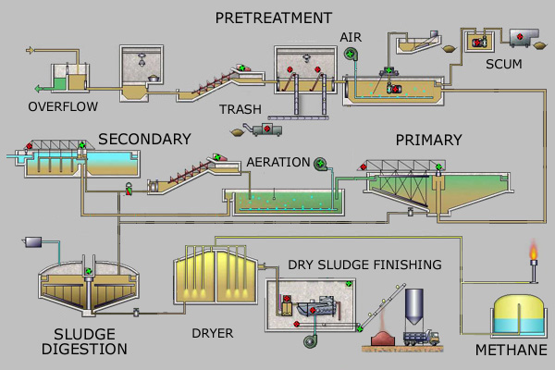  Schematic Drawing of  Wastewater Treatment Proces→  - Case Study  A wastewater treatment plant designed by the instructor will be shown in the class for case study. Kerya Water Reclamation Center is a local wastewater treatment plant constructed on the reclaimed land in the west coast of Hsinchu City, Northern Taiwan. The plant has a treatment capacity of 30,000 cubic meter per day at first stage. It will be expanded to 130,000 cubic meter per day at final stage to serve a population of 400,000 persons. Kerya is a tertiary treatment plant with activated sludge process and sand filtration. Its effluent is disinfected by UV light before discharging to the sea.  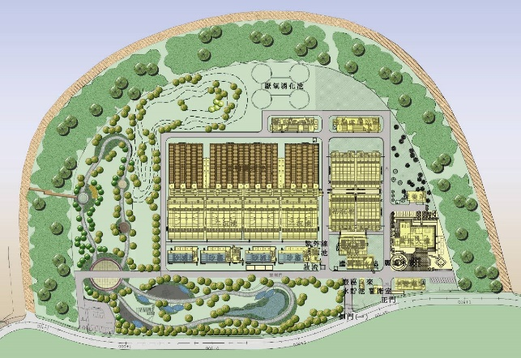  Plant Layout of  Kerya Water Reclamation Center,  Hsinchu City, Taiwan →  - Exercises  - It is required to treat wastewater to meet applicable effluent standards before discharging to a river. What are the major pollutants and their concentration limitations in these effluent standards? Are the concentration limitations for these major pollutants different in each specific effluent receiving waterbody?  - What are the possible beneficial use on the by-products derived from the processing of wastewater and solids in a wastewater treatment plant?  - List the kind of pumps commonly used for delivering liquid and solid streams in a wastewater treatment plant.  - Compare the rectangular and circular sedimentation tanks for use in a wastewater treatment plant, which is better?  - How many biological treatment processes could be used to treat domestic wastewater?

Course Topic
Environmental Biotechnology
Dr. I-Chieh Chien
Brief Introduction | Topic  Warning! Big waves are coming! Let's talk about tsunamis and storm surges.  Lecturer  Professor Tso-Ren Wu (吳祚任 教授) National Central University  Course subject  In this course, the students are expected to learn the physics of Tsunami and Storm Surge. Including the feature of long waves, short waves, wind waves, tsunamis, and storm surges. Shallow water wave theory will also be introduced. The procedures of the warning system in USA and Taiwan will be introduced, too.  Brief Abstract  Tsunamis and storm surges are devastated nature hazards on Earth. However, not many people understand the sciences behind them. In this course, we will introduce the physics of tsunami and storm surges. In-class experiments will be conducted to have a better and fast understanding of the theory. The differences between long waves and short waves will be emphasized. The students are expected to learn the basic theory of wave dynamics through interesting observations. In the end, the strategies of how to survive in these events will be introduced.  All you need is just bring your curiosity with you !

Course Topic
Advanced Materials and Green Technology
Dr. Chao-Tsai Huang
Brief Introduction | Topic  Advanced Materials and Green Technology  Lecturer  Dr. Chao-Tsai (CT) Huang Assistant Professor  Department of Chemical and Materials Engineering, Tamkang University  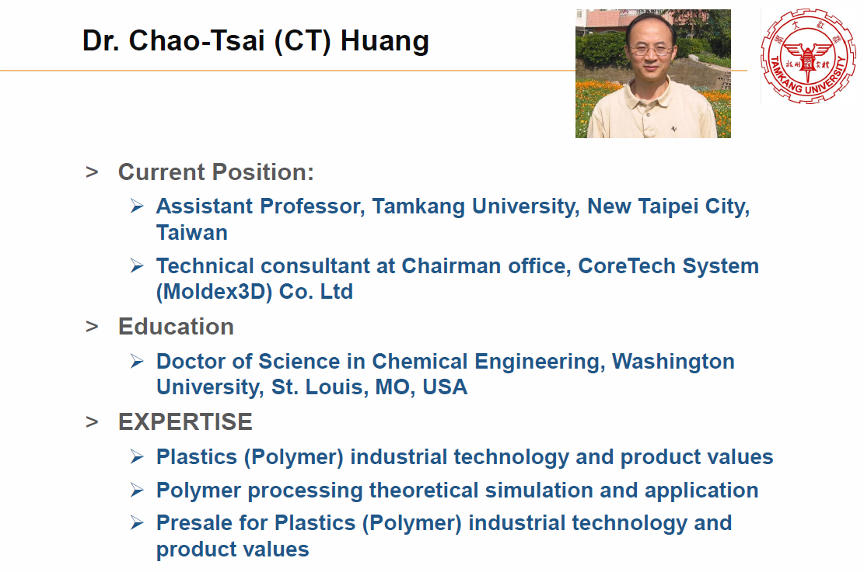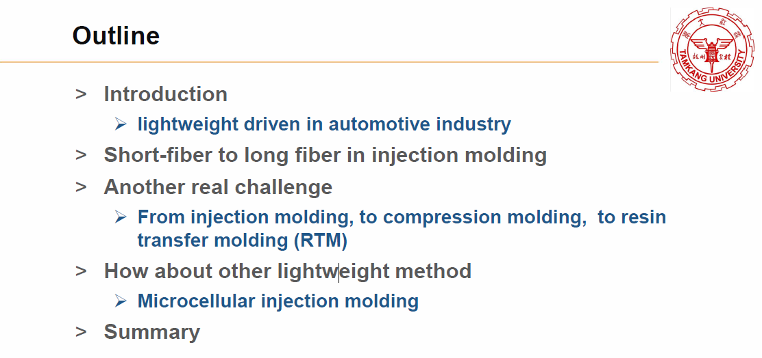

Course Topic
Green Energy Materials
Dr. Yu-Yao Hsiao
Brief Introduction | Topic  New Energy Introduction  Lecturer  Dr. Steve Y.Y.Hsiao General Manager Olin –Taiwan  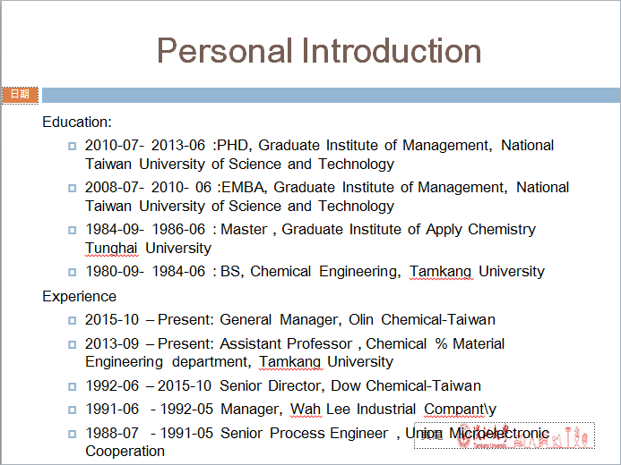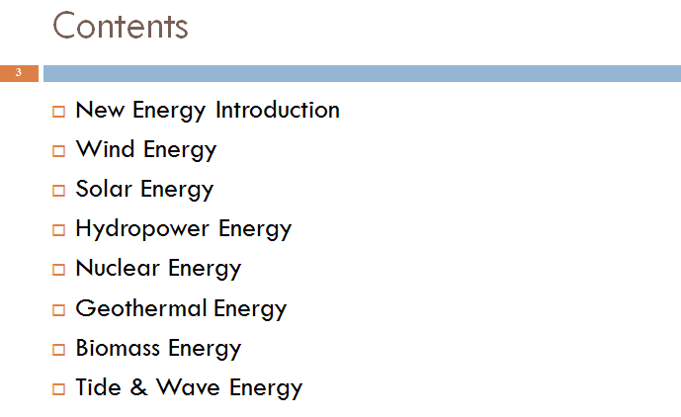

Course Topic
Green Membrane Materials
Dr. Liao-Ping Cheng
Brief Introduction | Topic  Polymeric Membranes：Preparation, Characterization, and Applications  Lecturer  Liao-Ping Cheng, Professor  Department of Chemical and Materials Engineering, Tamkang University  Course subject  - Membrane Definitions  - Types of Porous Membranes  - Main Applications  - Physical Properties  - Membrane Preparation Methods

Course Topic
Electrochromic Materials and Devices
Dr. Cheng-Lan Lin
Brief Introduction | Topic  Electrochromic Materials and Devices  Lecturer  Cheng-Lan Lin, Associate Professor  Department of Chemical and Materials Engineering, Tamkang University  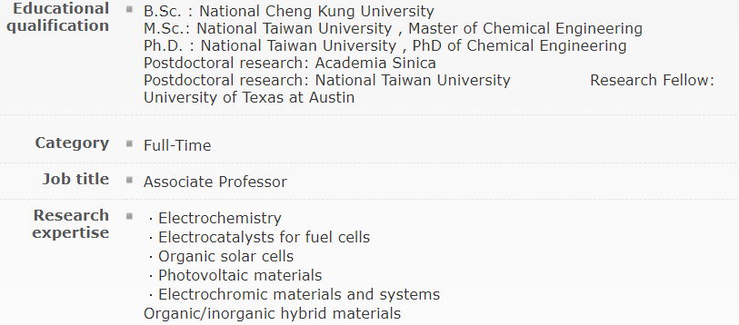  Course subject  

