Mysophobia vs. Hoarding Disorder

Mysophobia
Germophobia is a term used to describe a pathological fear of germs, bacteria, uncleanliness, contamination, and infection. Germophobia, also known as mysophobia, verminophobia, and bacillophobia, is most commonly associated with obsessive-compulsive disorder (OCD) but can present in a wide variety of people. Individuals with germophobia may feel compelled to excessively wash their hands and to take other precautions against contamination.

Germs are everywhere, and anyone practicing good hygiene and healthy living should take general precautions against contamination. Living life means sometimes encountering dirt, illness, or bacteria, but for some individuals, fear of coming into contact with germs significantly interferes with their lives. People with mysophobia struggle to evaluate which situations are dangerous, as they feel worried or panicked when encountering daily scenarios which involve germs. They will take extensive measure to avoid contamination or decontaminate themselves and the spaces they inhabit.

Causes of Mysophobia
People are at higher risk of developing phobias when anxiety or depression run in their family. Some people may develop mysophobia after experiencing a traumatic event, whereas others may start focusing on germs as a result of their anxiety. Some experts assert that the increased use of hygiene items, like toilet seat covers and hand sanitizers, has contributed to the rise of mysophobia in the United States. People with obsessive-compulsive disorder (OCD) are at higher risk for developing mysophobia because they may experience obsessive thoughts about germs and compulsively clean or sanitize their house or workspace.

Signs of Mysophobia

- avoiding places perceived as germ-filled
- spending excessive time cleaning and decontaminating
- washing hands obsessively
- refusing to share personal items
- avoiding physical contact with others
- fearing contamination of children
- avoiding crowds or animals

When a person is exposed to germs or potential contamination, they may experience the physical symptoms of panic, such as increased heart rate, nausea, shortness of breath, sweating, etc. In order to receive a diagnosis, there must also be evidence that the fear of germs has interfered significantly with the individual’s daily life and relationships. A person with mysophobia will find that their interactions with others and ability to travel and to work is affected by the desire to avoid contamination or illness.

Treatment Options
Mysophobia is usually treated with therapy, medication, or a combination of the two. Antidepressant medications known as SSRIs are frequently prescribed to help manage symptoms of anxiety. Exposure therapy is also used to treat mysophobia, as individuals become gradually used to reversing behaviors in a way that feels safe and gradual (i.e. increasing time in between hand washing). Cognitive behavioral therapy can also help an individual test the reality of irrational thought patterns they have about germs and contamination. There are many mental health professionals who specialize in phobias, so never hesitate to speak up about your specific symptoms and how they impact your life.

Action Steps

Educate yourself – One of the challenges of overcoming mysophobia is learning to correct irrational thoughts you have about germs and contamination. Reading or watching videos about how bacteria are a natural part of our bodies and our environment can help you manage fear and worry.

Find support – Millions of Americans suffer from a specific phobia, so take some time to check out what support is available to you in your community. In-person and online support groups can be an encouraging force in the lives of people who want to manage their anxiety about germs. Also, do not feel embarrassed to tell friends and family about your phobia and how they can support you in your treatment.

Recruit a professional – It is difficult to overcome a phobia without the help of a professional. Talk to your doctor or a mental health professional about what therapy approaches and/or medications could help you begin to manage your anxiety and reduce obsessive behaviors that inhibit your life. They may need to do further evaluation to determine if you have OCD or another anxiety disorder. If they don’t have experience working with mysophobia, don’t hesitate to ask for a referral to someone with expertise.

Though mysophobia can feel overpowering, it is a very treatable condition. With the right knowledge and support, you can begin to learn to manage your anxiety about germs and live a full and healthy life.

Hoarding disorder
A hoarding disorder is where someone acquires an excessive number of items and stores them in a chaotic manner, usually resulting in unmanageable amounts of clutter. The items can be of little or no monetary value.

Hoarding is considered a significant problem if:
- the amount of clutter interferes with everyday living – for example, the person is unable to use their kitchen or bathroom and cannot access rooms
- the clutter is causing significant distress or negatively affecting the quality of life of the person or their family – for example, they become upset if someone tries to clear the clutter and their relationship suffers
Hoarding disorders are challenging to treat because many people who hoard frequently do not see it as a problem, or have little awareness of how it's affecting their life or the lives of others. Many do realize they have a problem but are reluctant to seek help because they feel extremely ashamed, humiliated or guilty about it.

Why someone may hoard?
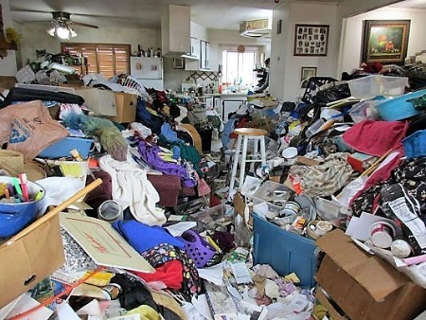
The reasons why someone begins hoarding are not fully understood. It can be a symptom of another condition. For example, someone with mobility problems may be physically unable to clear the huge amounts of clutter they have acquired, and people with learning disabilities or people developing dementia may be unable to categorise and dispose of items.

Mental health problems associated with hoarding include:
- severe depression
- psychotic disorders, such as schizophrenia
- obsessive compulsive disorder (OCD)

In some cases, hoarding is a condition in itself and often associated with self-neglect. These people are more likely to:
- live alone
- be unmarried
- have had a deprived childhood, with either a lack of material objects or a poor relationship with other members of their family
- have a family history of hoarding
- have grown up in a cluttered home and never learned to prioritise and sort items

Many people who hoard have strongly held beliefs related to acquiring and discarding things, such as: "I may need this someday" or "If I buy this, it will make me happy". Others may be struggling to cope with a stressful life event, such as the death of a loved one.


Attempts to discard things often bring up very strong emotions that can feel overwhelming, so the person hoarding often tends to put off or avoid making decisions about what can be thrown out. The person may keep the items for reasons that are not obvious to other people, such as for sentimental reasons, or feeling the objects appear beautiful or useful. Most people with a hoarding disorder have a very strong emotional attachment to the objects.

What's the difference between hoarding and collecting?
Many people collect items such as books or stamps, and this is not considered a problem. The difference between a "hoard" and a "collection" is how these items are organized.

A collection is usually well ordered, and the items are easily accessible. A hoard is usually very disorganized, takes up a lot of room and the items are largely inaccessible. For example, someone who collects newspaper reviews may cut out the reviews they want and organize them in a catalogue or scrapbook. Someone who hoards may keep large stacks of newspapers that clutter their entire house and mean it's not actually possible to read any of the reviews they wanted to keep.

Signs of a hoarding disorder
Someone who has a hoarding disorder may typically:
- keep or collect items that may have little or no monetary value, such as junk mail and carrier bags, or items they intend to reuse or repair
- find it hard to categorise or organise items
- have difficulties making decisions
- struggle to manage everyday tasks, such as cooking, cleaning and paying bills
- become extremely attached to items, refusing to let anyone touch or borrow them
- have poor relationships with family or friends

Hoarding can start as early as the teenage years and gets more noticeable with age. For many, hoarding becomes more problematic in older age. It's thought that around 1 or 2 people in every 100 have a problem with hoarding that seriously affects their life.

Items that are often hoarded include:
- newspapers and magazines
- books
- clothes
- leaflets and letters, including junk mail
- bills and receipts
- containers, including plastic bags and cardboard boxes
- household supplies

Some people also hoard animals, which they may not be able to look after properly. More recently, hoarding of data has become more common. This is where someone stores huge amounts of electronic data and emails that they're extremely reluctant to delete.

Why hoarding disorders are a problem?
A hoarding disorder can be a problem for several reasons. It can take over the person's life, making it very difficult for them to get around their house. It can cause their work performance, personal hygiene and relationships to suffer. The person hoarding is usually reluctant or unable to have visitors or even allow tradesmen in to carry out essential repairs, which can cause isolation and loneliness. The clutter can pose a health risk to the person and anyone who lives in or visits their house. For example, it can:
- make cleaning very difficult, leading to unhygienic conditions and encouraging rodent or insect infestations
- be a fire risk and block exits in the event of a fire
- cause trips and falls
- fall over or collapse on people, if kept in large piles

What you can do if you suspect someone is hoarding?
If you think a family member or someone you know has a hoarding disorder, try to persuade them to come with you to see a general practitioner. This may not be easy, as someone who hoards might not think they need help. Try to be sensitive about the issue and emphasize your concerns for their health and wellbeing.

Reassure them that nobody is going to go into their home and throw everything out. You're just going to have a chat with the doctor about their hoarding to see what can be done and what support is available to empower them to begin the process of decluttering. It's generally not a good idea to get extra storage space or call in the council or environmental health to clear the rubbish away. This won't solve the problem and the clutter often quickly builds up again.

How hoarding disorders are treated?
It's not easy to treat hoarding disorders, even when the person is prepared to seek help, but it can be overcome. The main treatment is cognitive behavioral therapy (CBT). The therapist will help the person to understand what makes it difficult to throw things away and the reasons why the clutter has built up.
his will be combined with practical tasks and a plan to work on. It's important the person takes responsibility for clearing the clutter from their home. The therapist will support and encourage this.

Antidepressant medicines called selective serotonin reuptake inhibitors (SSRIs選擇性5-羥色胺再攝取抑制劑，也稱選擇性血清素再攝取抑制劑，是一類常用的抗憂鬱藥) have also been shown to help some people with hoarding disorders.

Cognitive behavioral therapy (CBT)
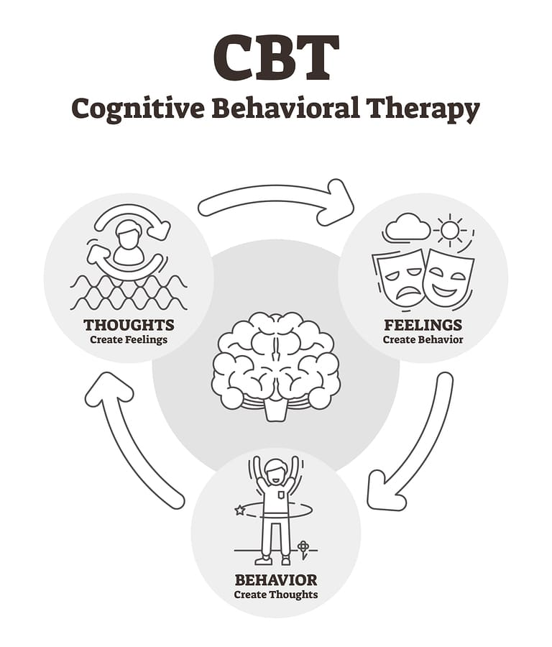
CBT is a type of therapy that aims to help you manage your problems by changing how you think (cognitive) and act (behavior). It encourages you to talk about how you think about yourself, the world and other people, and how what you do affects your thoughts and feelings.

Regular sessions of CBT over a long period of time are usually necessary and will almost always need to include some home-based sessions, working directly on the clutter. This requires motivation, commitment and patience, as it can take many months to achieve the treatment goal. The goal is to improve the person's decision-making and organizational skills, help them overcome urges to save and, ultimately, clear the clutter, room by room.

The person gradually becomes better at throwing things away, learning that nothing terrible happens when they do and becomes better at organizing items they insist on keeping. At the end of treatment, the person may not have cleared all their clutter, but they will have gained a better understanding of their problem.

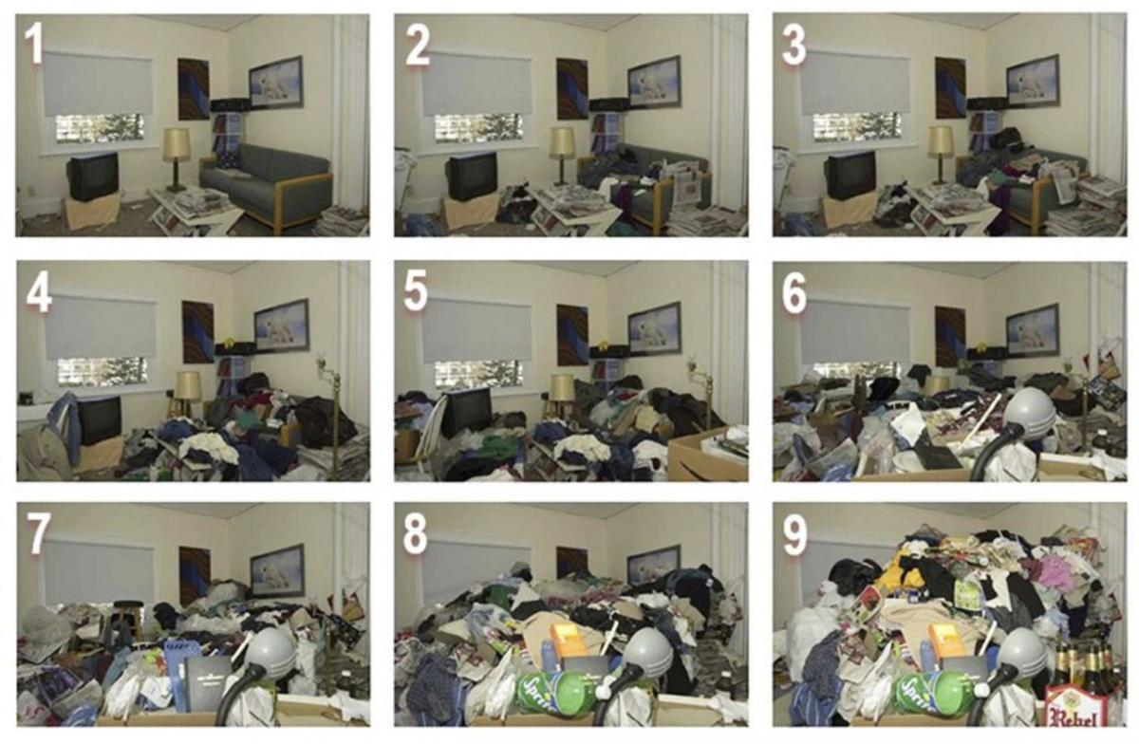
https://www.psycom.net/mysophobia-germophobia
https://www.nhs.uk/mental-health/conditions/hoarding-disorder/

